**File Move**

**Summary:**

This document will explain how to move a file.

**Step 1:** Double click **on File Move.zappy**, to start the execution**.**

**Step 2:** Run Zappy Task window will open on screen. Now Click on **OK** to execute the automation.

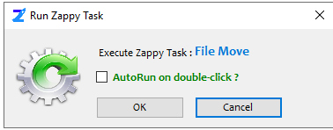

**Step 3:** After click on **OK,** Select the **file** which you want move.

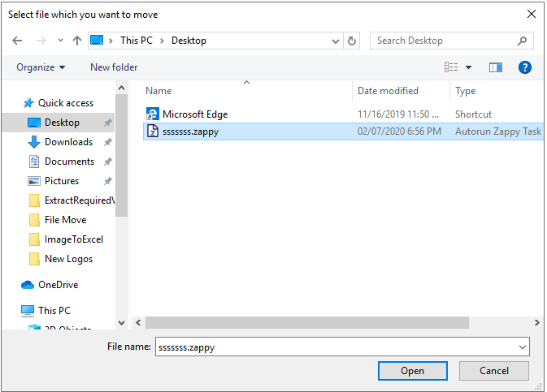

**Step 4:** Select the location where you want to move the file.

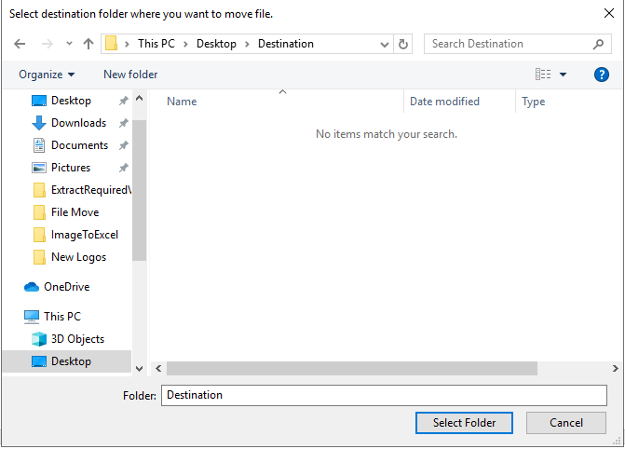

**Output:**

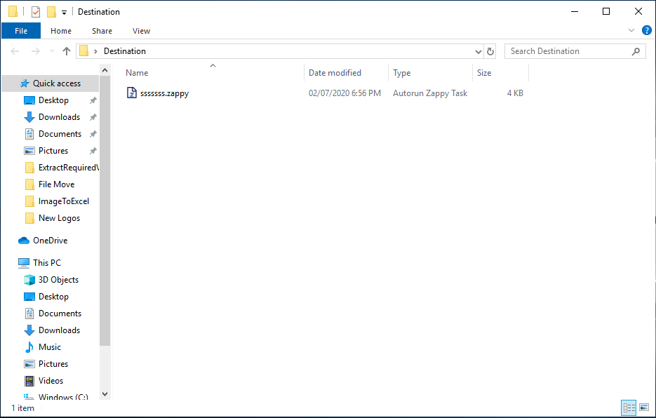

**In this way we can use this automation to move any file.**